|  |  |  |  |
| --- | --- | --- | --- |
| Sensor Type | Sensors pins | Arduino Mega | Note |
| Ultrasonic 1 | Echo  Trig  GND  Vcc | 22  23  GND  5V | Parking slot 1 |
| Ultrasonic 2 | Echo  Trig  GND  Vcc | 24  25  GND  5V | Parking slot 2 |
| Ultrasonic 3 | Echo  Trig  GND  Vcc | 26  27  GND  5V | Parking slot 3 |
| Ultrasonic 4 | Echo  Trig  GND  Vcc | 28  29  GND  5V | Parking slot 4 |
| Ultrasonic 5 | Echo  Trig  GND  Vcc | 30  31  GND  5V | Parking slot 5 |
| Ultrasonic 6 | Echo  Trig  GND  Vcc | 32  33  GND  5V | Parking slot 6 |
| Ultrasonic 7 | Echo  Trig  GND  Vcc | 34  35  GND  5V | Parking slot 7 |
| Ultrasonic 8 | Echo  Trig  GND  Vcc | 36  37  GND  5V | Parking slot 8 |
| Ultrasonic 9 | Echo  Trig  GND  Vcc | 38  39  GND  5V | Sensor at the entrance gate |
| Ultrasonic 10 | Echo  Trig  GND  Vcc | 40  41  GND  5V | Sensor at the Exit gate |
| LCD16x2 | Vss  Vcc  Vo  (Contrast pin)  Rs  R/W  E  DB4  DB5  DB6  DB7  A  K | GND  5V  To Vo in potentiometer  1  GND  2  4  5  6  7  5V  GND | Potentiometer used to adjust contrast of the LCD |
| Servo motor 1 | GND  VCC  Signal | GND  5V  11 | Motor at the entrance gate |
| Servo motor 2 | GND  VCC  Signal | GND  5V  12 | Motor at the  Exit gate |
| RFID 1 | SDA/SS  SCK  MOSI  MISO  GND  RST  VCC | 9  52  51  50  GND  8  3.3V | RFID reader at the entrance gate |
| RFID 2 | SDA/SS  SCK  MOSI  MISO  GND  RST  VCC | 10  52  51  50  GND  8  3.3V | RFID reader at the Exit gate |
| RGB LED 1 | GND  RED pin  Green Pin | GND  48  49 | RGB LED at the entrance gate ,  RED Pin and Green are connected to 220 Ω resistance |
| RGB LED 2 | GND  RED pin  Green Pin | GND  46  47 | RGB LED at the exit gate,  RED Pin and Green are connected to 220 Ω resistance |

Electrical system layout

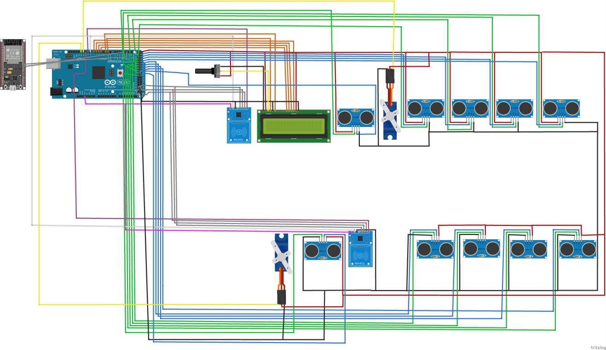

Color code

|  |  |
| --- | --- |
| Parameter | Color code |
| VCC |  |
| GND |  |
| Trigger |  |
| Echo |  |
| SDA |  |
| Communication (MOSI-MISO-SCK etc..) |  |
| Signal |  |
| RESET |  |